A Web-Based Egg Market Management System for Connecting Farmers and Consumers

This system is a digital marketplace that connects egg farmers, suppliers, and customers in one platform where eggs can be listed, purchased, and managed online.

The Problem

Lack of Digital Sales Platform
- Most egg selling is done offline, making it difficult for customers to easily find suppliers.

Poor Inventory and Order Management
Farmers usually track stock and sales manually, which can cause:
- Stock errors:
Incorrect tracking of available eggs can lead to shortages or overstocking.
- Order confusion:
Manual handling of orders may cause mix-ups, delays, or incorrect deliveries.
- Lost sales records:
Important transaction details may be misplaced or not recorded properly, affecting business tracking and profits.

Difficulty for Customers
Customers cannot easily:
- Compare prices:
Customers cannot easily check and compare egg prices from different sellers, making it harder to find the best deal.
- See egg availability:
Customers have no clear way to know if eggs are in stock, which can lead to inconvenience or wasted time.
- Order eggs online:
Without an online system, customers must order manually, making the process slower and less convenient.

Proposed Solution
The Web-Based Egg Market Management System will:
- Connect farmers directly to consumers
- Provide an online marketplace for eggs
- Allow farmers to manage inventory and orders
- Allow customers to browse and purchase eggs easily
- Provide admin monitoring and reports
- This improves efficiency, transparency, and accessibility in the egg market.

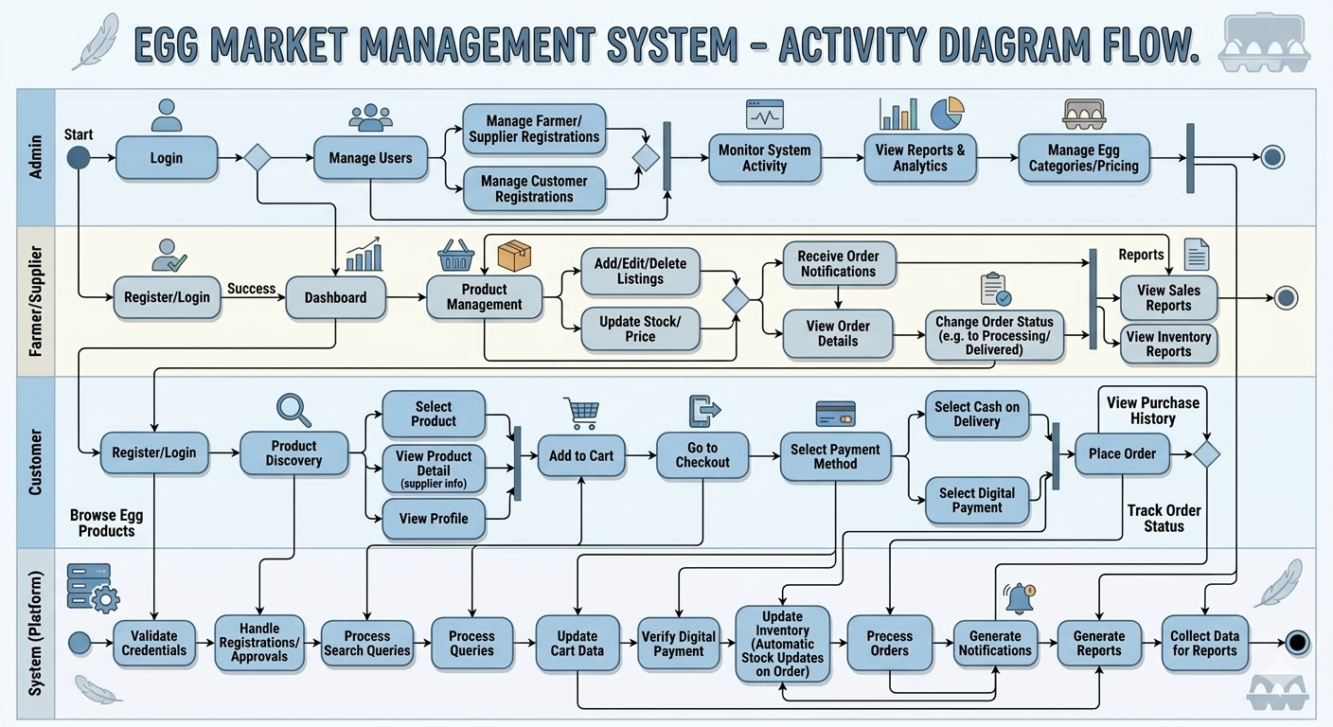
UML Activity Diagram:

